

AMERICAN INTERNATIONAL UNIVERSITY-BANGLADESH

COMPUTER GRAPHICS – PROJECT DOCUMENTATION

|  |  |
| --- | --- |
| **Course Name** | Computer Graphics |
| **Section** | K |
| **Course Tutor** | ANEEM AL AHSAN RUPAI |

**Group Members Information:**

|  |  |
| --- | --- |
| **Name** | **ID** |
| **RIDWAN CHOWDHURY** | **18-37598-1** |
| **JEBA FAWJIA** | **19-39815-1** |
| **T.M RAGIB SHAHRIER** | **19-39815-1** |
| **AHNAF SADMAN** | **16-32398-2** |

**Table of Content:**

|  |  |
| --- | --- |
| **Content List** | **Page No** |
| Introduction | 03 |
| Proposal | 03 |
| Schematic Diagram | 04-07 |
| List of Objects | 07-09 |
| Functions to Represent the Objects | 09-11 |
| Interactive Functions | 11-12 |
| Task Assignment and Codes of Functions | 12-14 |
| Output | 15-16 |
| Conclusion | 16 |

**Introduction**

Our project is based on the city scenario. We implemented the city scenario using OpenGL technology. The glut library is accessed by OpenGL.**OpenGL** (Open Graphics Library) is a cross-language, cross-platform application programming interface (API) for rendering 2D and 3D vector graphics. Altogether it would render an eye-pleasing City view scenario. Our program provides a fast and accurate rendering of the objects.

**Proposal**

This project is based on the City Scenario. In our project, there is Sun, and BigShip, SmallShip which are moved in an opposite direction. Also, we have UpperCar, LowerCar which are moved in an opposite direction. On the road, there is also a Truck and Bus. These Trucks and buses also moved in an opposite direction. There is some keyboard connection which is created.

These keyboard interactions can stop and move the car. Beside the road, there is nine-building in which two building has a clock and this city view is covered with some tree.

**Schematic Diagram**

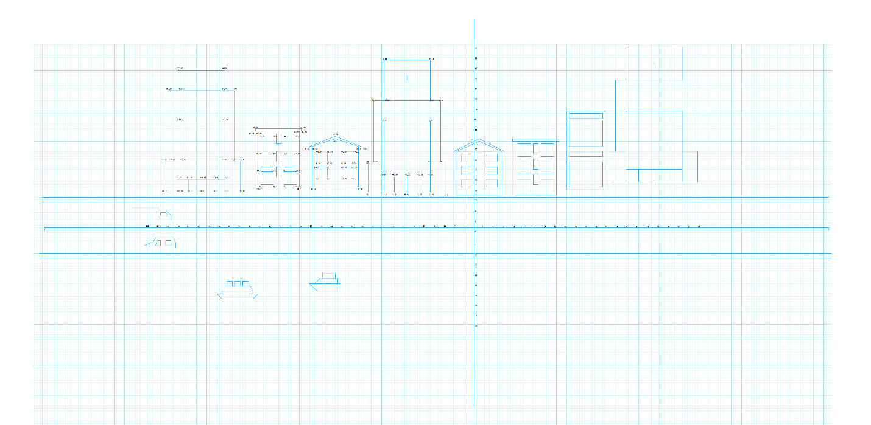

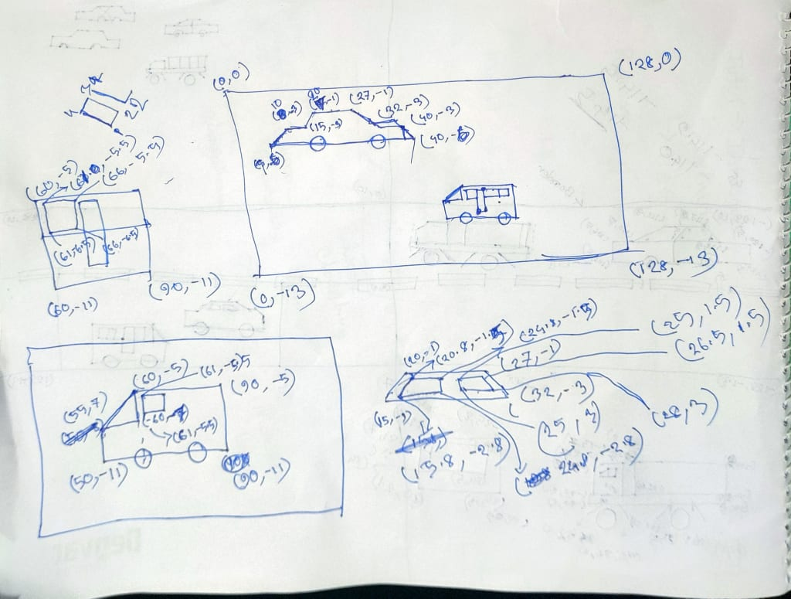

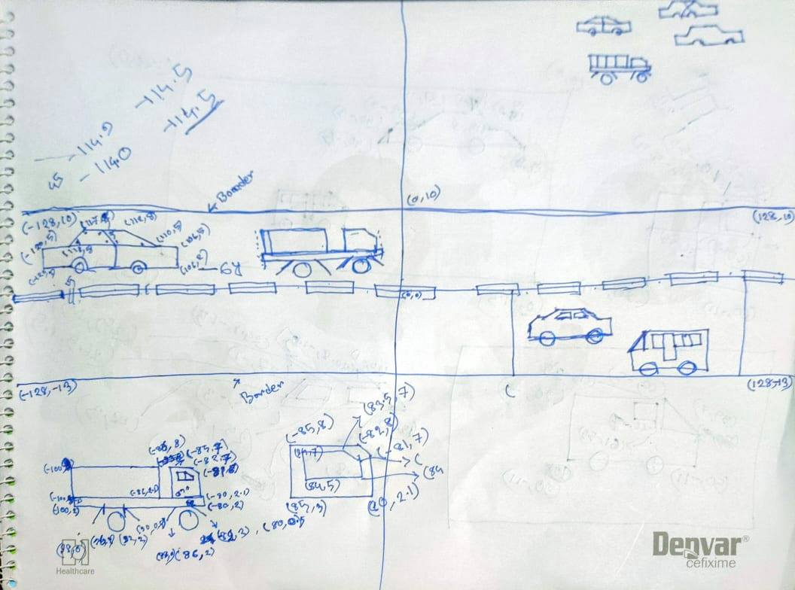

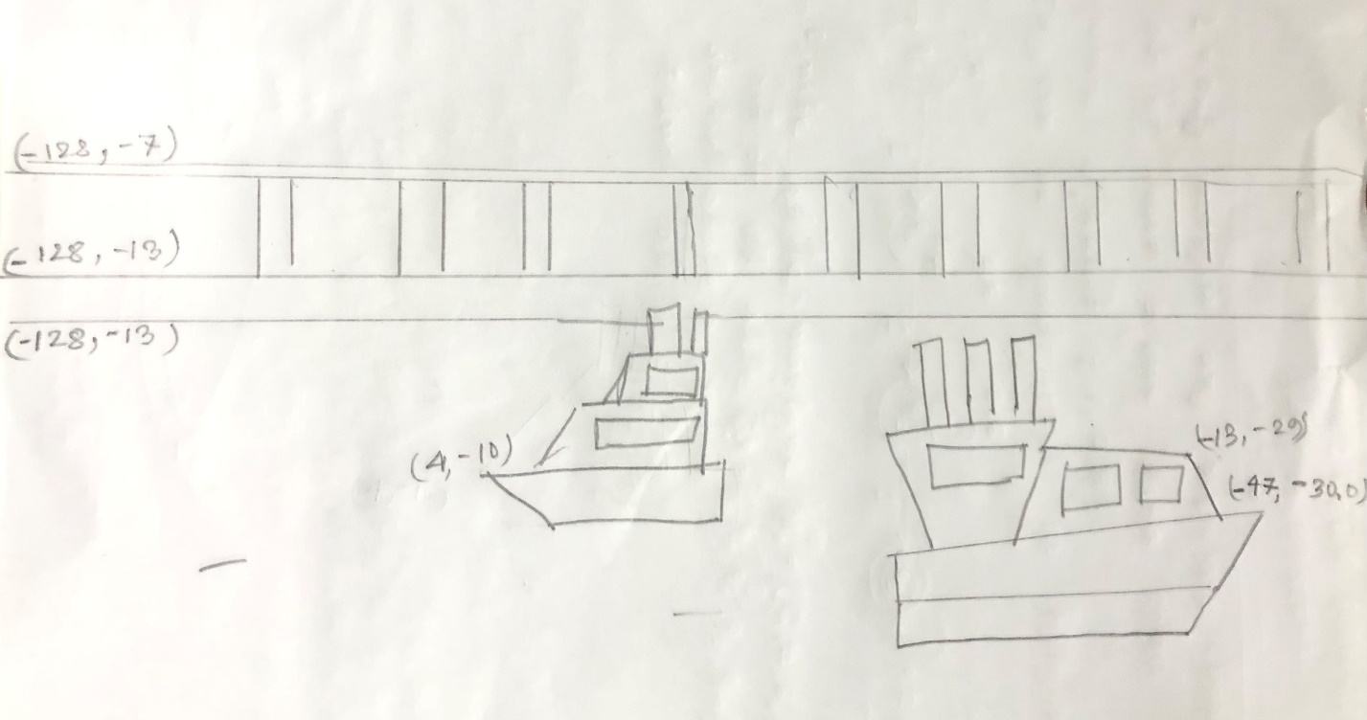

**List of Objects**

1. Sun
2. BigShip
3. SmallShip
4. UpperCar
5. LowerCar
6. Truck
7. Bus
8. Relling
9. Water
10. Clock1
11. Clock2
12. Boundery
13. Waterlines
14. Road
15. Building1
16. Building2
17. Building3
18. Building4
19. Building5
20. Building6
21. Building7
22. Building8
23. Building9
24. Tree1
25. Tree2
26. Tree3
27. Tree4
28. Tree5
29. Tree6
30. Tree7
31. Tree8
32. Tree9
33. Tree10
34. Sky Background
35. Cloud1
36. Cloud2
37. Airplane
38. Bird

**Funtions to Represent The Objects**

|  |  |  |
| --- | --- | --- |
| **Object** | **Function** | **ID** |
| bigship | Void bigship() | 306 |
| smallship | Void smallship () | 305 |
| water | Void water() | 301 |
| waterlines | Void waterlines() | 302 |
| boundery | Void boundery() | 303 |
| relling | Void relling() | 304 |
| Clock1 | Void clock1() | 101 |
| Clock2 | Void clock2() | 102 |
| LeftFirstBuilding | Void left_side_1stBuilding() | 103 |
| LeftSecondBuilding | Void left_side_2ndBuilding() | 104 |
| LeftThirdBuilding | Void left_side_3rdBuilding() | 105 |
| LeftFourthBuilding | Void left_side_4thBuilding() | 106 |
| RightFirstBuilding | Void right_side_1stBuilding() | 107 |
| RightSecondBuilding | Void right_side_2ndBuilding() | 108 |
| RightThirdBuilding | Void right_side_3rdBuilding() | 109 |
| RightForthBuilding | Void right_side_4thBuilding() | 110 |
| Middle Building | Void middle_building() | 111 |
| Sky sun | Void BsS() | 112 |
| LeftTree | Void left_side_tree() | 113 |
| RightTree | Void right_side_tree() | 114 |
| Upper car | Void CarUpper() | 201 |
| Update upper car | UpdateUpperCar() | 202 |
| Truck | Void TruckUpper() | 203 |
| Update upper truck | UpdateUpperTruck() | 204 |
| Lower car | Void LowerCar() | 205 |
| Update lower car | UpdateLowerCar() | 206 |
| Bus | Void LowerBus() | 207 |
| Update lower bus | UpdateLowerBus() | 208 |
| Road | Void Road() | 209 |
| Key press update | HandleKeypress() | 210 |
| Cloud_one | Void cloudone | 310 |
| Cloud_two | Void_cloudtwo | 311 |
| Areoplane | Void_plane | 312 |
| Birds | Void_birds | 313 |
| Plan | Void plan () | 500 |
| Update plan | updateplan | 501 |
| Cloud1 | cloud1 | 502 |
|  |  |  |
| UpdateCloud1 | updatecloud1 | 503 |
| cloud2 | updatecloud2 | 505 |
| Cloud3 | Cloud3() | 506 |

**Interactive Functions**

|  |  |  |
| --- | --- | --- |
| **Interactive Functions** | **Interaction** | **ID** |
| updateUpperCar() | Changes the upper car position to X direction | 202 |
| updateUpperTruck() | Changes the upper truck position to X direction | 204 |
| updateLowerCar() | Changes the lower car position to -X direction | 206 |
| updateLowerBus() | Changes the lower car position to -X direction | 208 |
| BigShipMove_update() | Changes the big ship position to X direction | 307 |
| SmallShipMove_update1() | Changes the big ship position to -X direction | 308 |
| HandleKeypress() | Stops and runs the vehicles based on key press interactions | 210 |
|  |  |  |

**Task Assignment and Codes of Funchtions**

**Contribution Table:**

|  |  |  |  |  |
| --- | --- | --- | --- | --- |
| **Member-1** | **Member-2** | **Member-3** | **Member-4** | **TOTAL** |
| 25% | 25% | 25% | 25% | 100% |

|  |  |
| --- | --- |
| **Name**  **ID** | **Contribution in Project** |
| **Member-1**  **RIDWAN CHOWDHURY** | 1. CarUpper 2. TruckUpper 3. LowerCar 4. LowerBus 5. Road 6. CarUpper Animation 7. TruckUpper Animation 8. LowerCar Animation 9. LowerBus Animation |
| **Member-2**  **T.M RAGIB SHAHRIER** | 1. clock1 2. clock2 3. left_side_1stBuilding 4. left_side_2ndBuilding 5. left_side_3rdBuilding 6. left_side_4thBuilding 7. right_side_1stBuilding 8. right_side_2ndBuilding 9. right_side_3rdBuilding 10. right_side_4thBuilding 11. middle_building 12. Background sky 13. left_side_tree 14. right_side_tree |
| **Member-3**  **JEBA FAWJIA** | 1. Water 2. WaterLines 3. BigShip 4. SmallShip 5. Boundery 6. Relling 7. BigShip Animation 8. SmallShip Animation |
| **Member-4**  **AHNAF SADMAN** | **1.cloud**  **2.Plane**  **2.cloud2**  **3 . cloud3** |

**OUTPUT**

|  |  |
| --- | --- |
| **Day View** |  |
|  |  |
|  |  |
|  |  |

**Conclusion**

We have implemented an automatic view of City scenario where The program runs everything with some relevant sound effect regarding the view effect of the scene. We also have key board interaction which can move two car ,bus and truck .This project represent beautiful sea side road city scenery.